LINUX SYSTEM ADMINISTRATION LAB

EX. NO : 1
IDENTIFY THE CURRENT SHELL AND LENGTH OF THE STRING

PROGRAM:
#!/bin/bash
echo "The Current Shell is = $SHELL"
str1="Welcome to Rathinam College"
echo $str1
len=${#str1}
echo "Length of the String = $len"

OUTPUT :
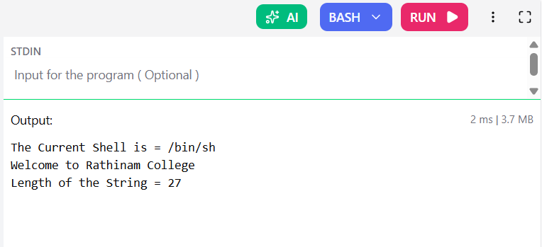

EX.NO:2
COUNT BACKWARDS FOR 100 TO 0 USING FOR LOOP

PROGRAM:
#!/bin/bash
echo "To Count Backwards for 100 to 0 Using For Loop"
c=0
for (( i =100; i >= 0; --i ))
do
echo "$i"
s=$[c++]
done
echo "Count = $s"

OUTPUT:
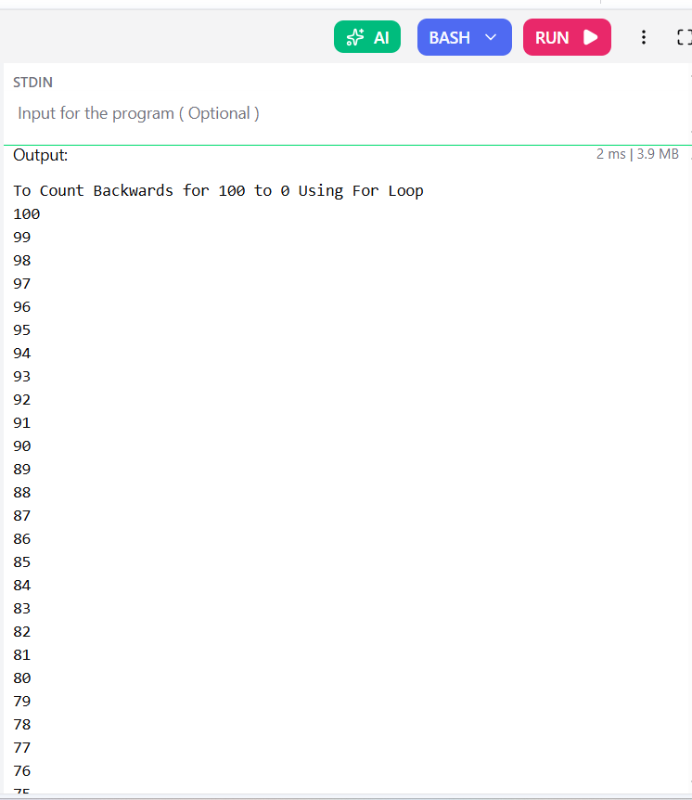
EX.NO:3

PROGRAM:
#!/bin/bash
for ((i=5; i>=1; i--))
do
for ((j=1; j<=i; j++))
do
echo -n "*"
done
echo
done

OUTPUT:
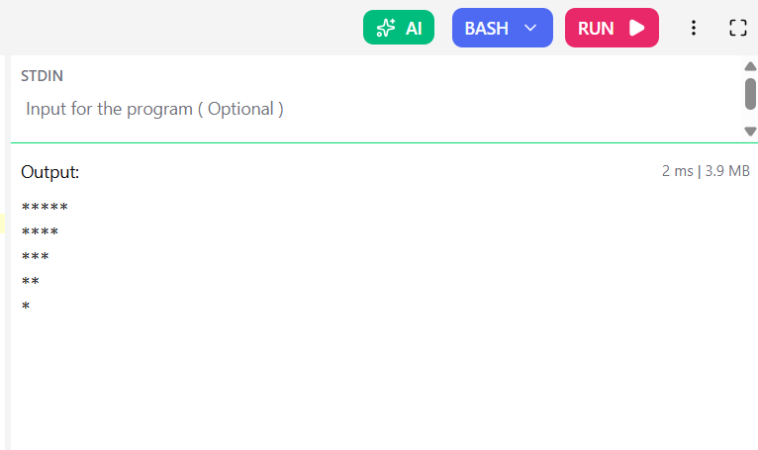

EX NO: 4

PROGRAM:
#!/bin/bash
echo "To print even and odd numbers and their count and sums"
even_count=0
odd_count=0
even_sum=0
odd_sum=0

echo "Even numbers from 0 to 100:"
for (( i=0; i<=100; i++ ))
do
if (( i % 2 == 0 )); then
echo -n "$i "
((even_count++))
((even_sum+=i))
fi
done

echo -e "\n\nOdd numbers from 0 to 100:"
for (( i=0; i<=100; i++ ))
do
if (( i % 2 != 0 )); then
echo -n "$i "
((odd_count++))
((odd_sum+=i))
fi
done
OUTPUT:
